

***An internship report submitted by***

**THEJASWINI KISHORE - URK21CS1067**

**SUMITHA R – URK21CS1038**

***in partial fulfillment for the award of the degree of***

**BACHELOR OF TECHNOLOGY**

***in***

**COMPUTER SCIENCE AND ENGINEERING**

***under the supervision of***

**Dr. K. VIDHYA Assistant Professor**



**DIVISION** **OF COMPUTER SCIENCE AND ENGINEERING**

**KARUNYA INSTITUTE OF TECHNOLOGY AND SCIENCES**

(Declared as Deemed to be University under Sec-3 of the UGC Act, 1956)

**Karunya Nagar, Coimbatore - 641 114. INDIA**



**DIVISION OF COMPUTER SCIENCE AND ENGINEERING**

**BONAFIDE CERTIFICATE**

This is to certify that the report entitled, “DESIGN AND IMPLEMENTATION OF ATP MACHINE CONTROLLER” is a bonafide record of Internship work done at INTEL during the academic year 2022-2023 by

**(Reg. No: URK21CS1067, URK21CS1038)**

in partial fulfillment of the requirements for the award of the degree of Bachelor of Technology in Computer Science and Engineering of Karunya Institute of Technology and Sciences.

**Guide Signature**

Dr.Vidhya K

Assistant Professor

**ACKNOWLEDGEMENT**

First and foremost, I praise and thank ALMIGTHY GOD whose blessings have bestowed in me the will power and confidence to carry out my internship.

I am grateful to our beloved founders **Late. Dr. D.G.S. Dhinakaran, C.A.I.I.B, Ph.D** and **Dr. Paul Dhinakaran, M.B.A, Ph.D**, for their love and always remembering us in their prayers.

We entend Our tanks to **Dr. Prince Arulraj, M.E., Ph.D., Ph.D.,** our honorable vice chancellor, **Dr. E. J. James, Ph.D.,** and **Dr. Ridling Margaret Waller, Ph.D.,** our honorable Pro-Vice Chancellor(s) and **Dr. R. Elijah Blessing, Ph.D.,** our respected Registrar for giving me this opportunity to do the internship.

I would like to thank **Dr. Ciza Thomas, M.E., Ph.D.,** Dean, School of Engineering and Technology for her direction and invaluable support to complete the same.

I would like to place my heart-felt thanks and gratitude to **Dr. J. Immanuel John Raja, M.E., Ph.D.,** Head of the Division, Computer Science and Engineering for his encouragement and guidance.

I feel it a pleasure to be indebted to, Dr.Vidhya K, Designation, Division of CSE & Mr. Abhishek Nandy , Intel Designation for their invaluable support, advice and encouragement.

I also thank all the staff members of the School of CST for extending their helping hands to make this in Internship a successful one.

I would also like to thank all my friends and my parents who have prayed and helped me during the Internship.

**Team Name: Error 404**

**Team Members**

The project was carried out by :

* Thejaswini Kishore – [thejaswinikishore@karunya.edu.in](mailto:thejaswinikishore@karunya.edu.in)
* Sumitha R – [sumithar@karunya.edu.in](mailto:sumithar@karunya.edu.in)

**Mentor**

I would like to express my gratitude to my mentor for providing constant support and guidance throughout the internship.

* Dr.Vidhya K (Academic Mentor) [-vidhyak@karunya.edu](mailto:-vidhyak@karunya.edu)
* Mr. Abhishek Nandy(Industrial Mentor) - [abhisheknandy@theprograms.in](mailto:abhisheknandy@theprograms.in)

**Design and Implementation of ATP Machine Controller**

***Abstract*—** ATPs are designed to collect payment from consumers by cash, cheque, or DD. It will be unmanned and can be operated by the customers 24/7. It accepts cash/cheque/DD/pay order, issues an acknowledgment on every payment made and is a touchscreen and multimedia-based system. When the customer places the voucher/bill in the designated slot under the barcode scanner, the ATP will automatically get started. Suitable prompts are provided for guidance.

The ATP captures data from the voucher/bill and will display parameters on the monitor. A customer needs to choose the mode of payment. Once the amount is confirmed by the customer, the ATP will give directions on cash/cheque insertion. Parameters such as cheque number etc are read from the MICR fields and an acknowledgment is issued to the customer with the bill.

**Introduction**:

The ATP machine is an automatic machine which is used for the payment of electricity bill. ATPs are designed to collect payment from consumers by cash, cheque, or DD. It will be unmanned and can be operated by the customers 24/7. It accepts cash/cheque/DD/pay order, issues an acknowledgment on every payment made and is a touchscreen and multimedia-based system. When the customer places the voucher/bill in the designated slot under the barcode scanner, the ATP will automatically get started. Suitable prompts are provided for guidance. The ATP captures data from the voucher/bill and will display parameters on the monitor. A customer needs to choose the mode of payment. Once the amount is confirmed by the customer, the ATP will give directions on cash/cheque insertion. Parameters such as cheque number etc are read from the MICR fields and an acknowledgment is issued to the customer with the bill.

The ATP Machine has a touch screen, through which the consumers can enter their Service Number and pay the amount and get a receipt/statement of the amount paid. The machine has the provision to take currency notes. A separate slot will accept cheques in the same manner.

Machines of this new category are generally called Anytime payment kiosks. Apparently similar to the development of traditional mobile phones into smartphones, ATP machines have also progressively, though at a much slower pace, evolved into smart machines. Newer technologies at a lower cost of adoption, such as the large digital touch display, internet connectivity, cameras and various types of sensors, more cost-effective embedded computing power, digital signage, various advanced payment systems, and a wide range of identification technology (NFC, RFID, etc) have contributed to this development.. Integrated sensors and cameras also represent a source of such data as customer demographics and other locality-specific information. It also enables better customer engagement.

**BLOCK DIAGRAM:**

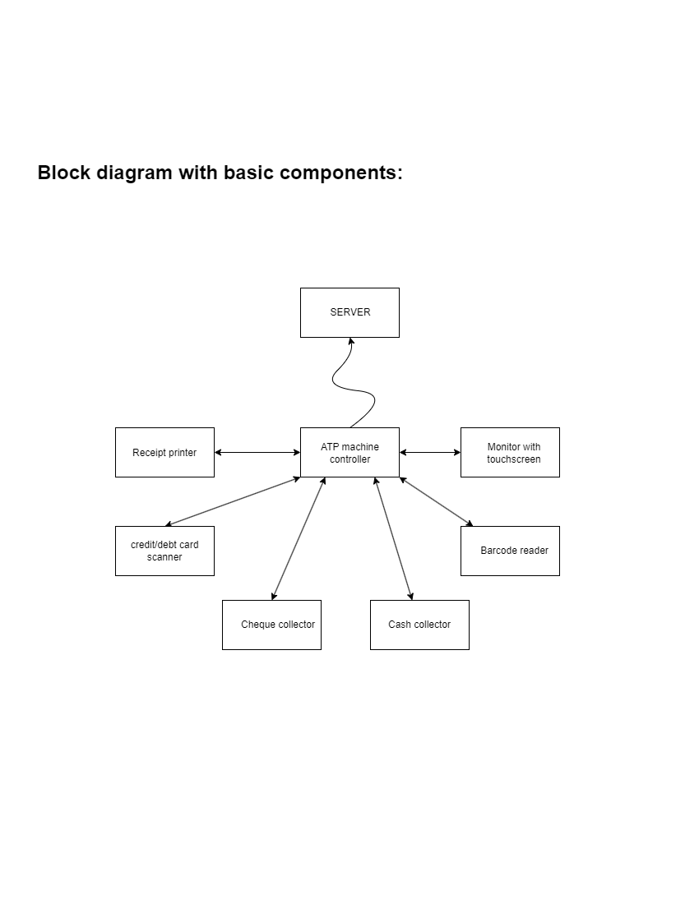

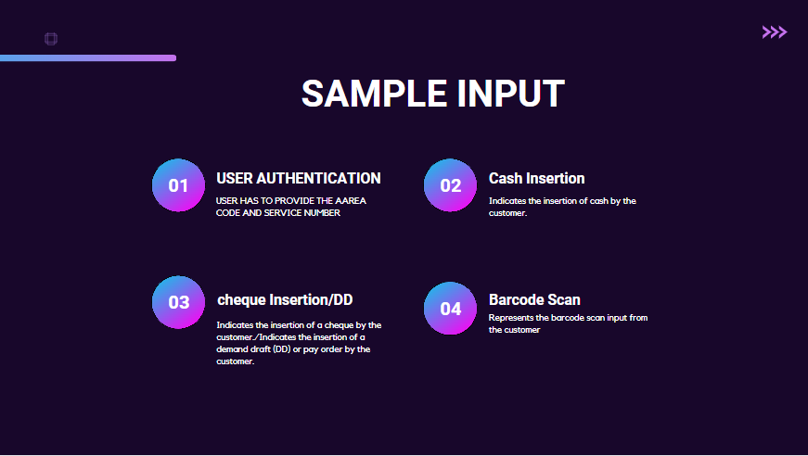

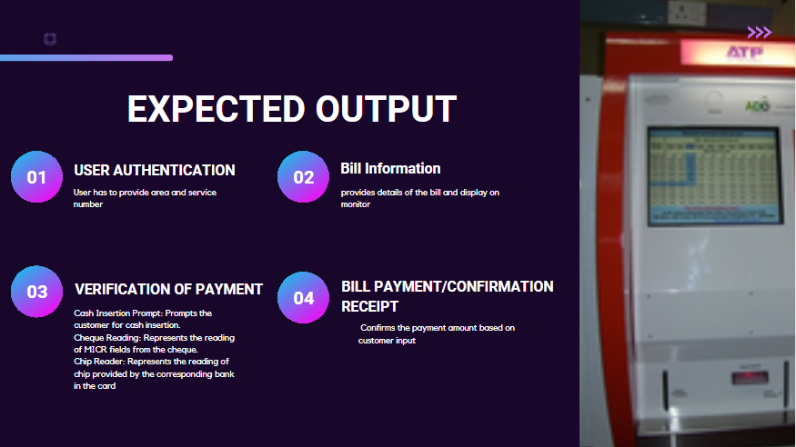

**FLOWCHART:**

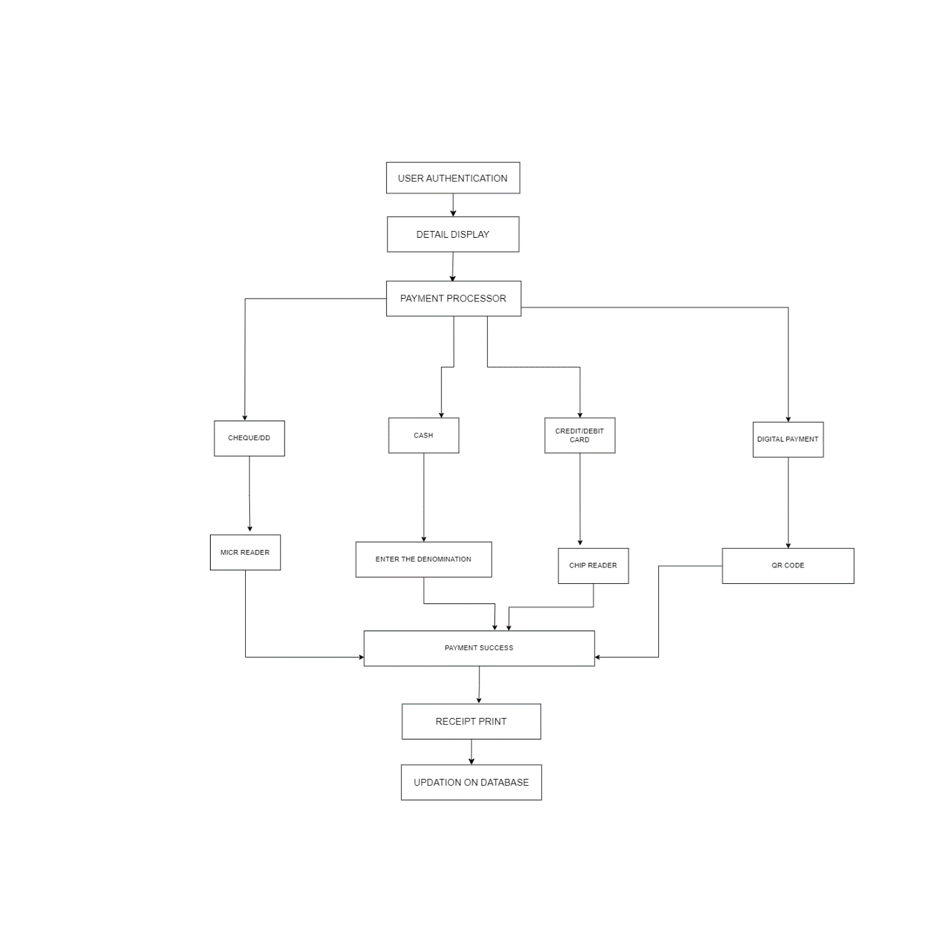

**FINITE STATE MACHINE(MEALY):**

The finite state diagram for the ATP system. Based on the problem statement, we can identify the following states:

1. IDLE: The initial state of the ATP.
2. STARTED: The ATP has been started, and an acknowledgment is issued with the voucher data.
3. CONFIRM_AMOUNT: The customer confirms the amount to be paid.
4. INSERT_CASH_CHEQUE: The customer inserts cash/cheque.
5. PROCESSING: The ATP processes the cash/cheque.
6. COMPLETED: The transaction is completed, and an acknowledgment is issued with the total amount and electricity charge.

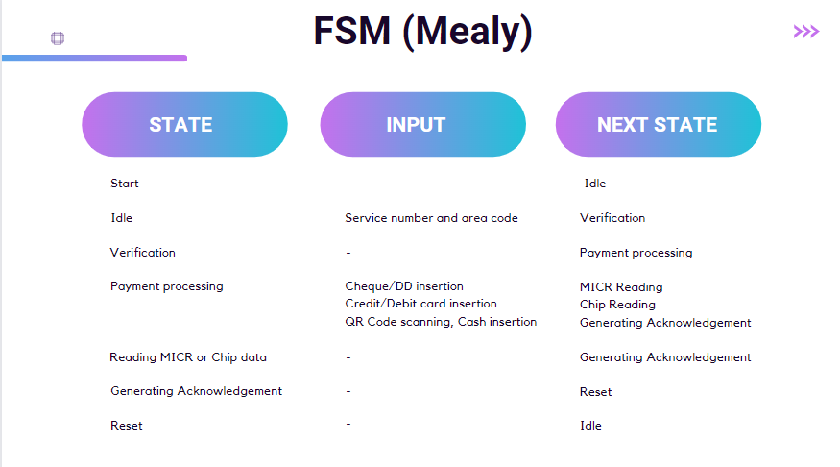

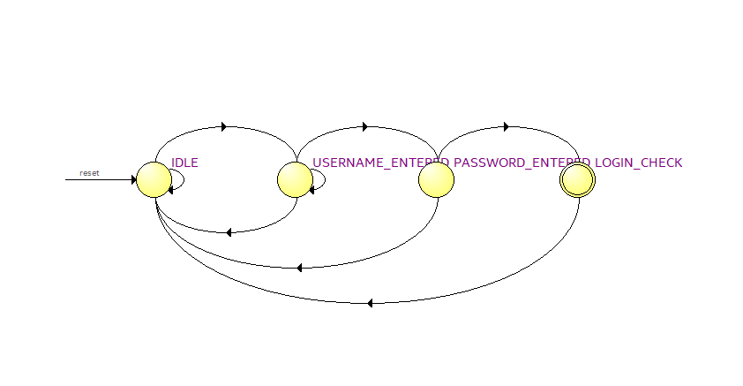

**RTL VIEWER:**

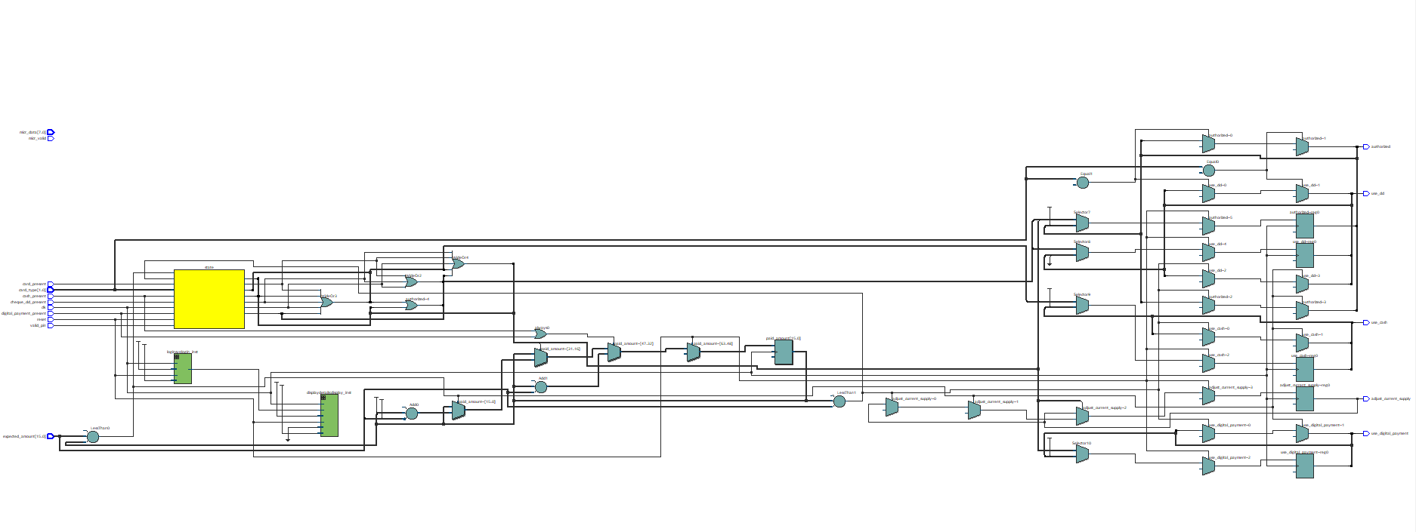

**Compilation Report:**

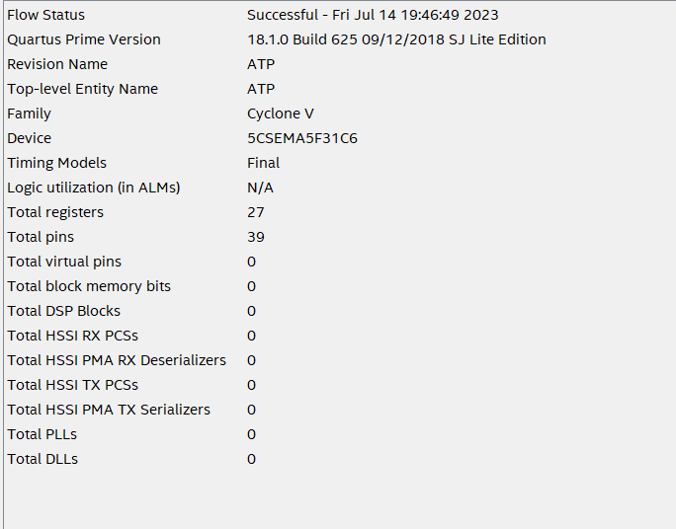

**Waveform:`**

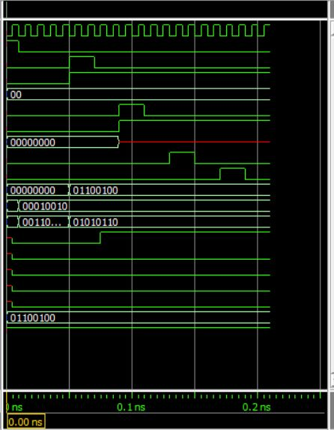

**Result:**

The ATP machine was successful, with the additional features of printing receipt along with adding the excess amount to the wallet. The ATP machine is successful in meeting the specifications laid out prior to the design.